Measurement Standards
# Source: AI Source: Provided by: [Data Path: Persons Table -> ID Column: 1, Name_En Column: Motasem Essam] -> From: [ChatGPT] on [7/17/2026]
Measurement Standards are officially recognized references used to define, realize, preserve, and reproduce units of measurement. They ensure that measurements are accurate, consistent, traceable, and comparable across different places, laboratories, industries, and countries.
Measurement standards form the foundation of metrology (the science of measurement) and support science, engineering, manufacturing, medicine, commerce, and international trade.

Definition
# Source: AI Source: Provided by: [Data Path: Persons Table -> ID Column: 1, Name_En Column: Motasem Essam] -> From: [ChatGPT] on [7/17/2026]
A Measurement Standard is a physical artifact, reference material, instrument, or precisely defined physical phenomenon that is used as the accepted reference for a unit of measurement.
It provides the basis for calibrating measuring instruments and ensuring measurement consistency.

Purpose of Measurement Standards
# Source: AI Source: Provided by: [Data Path: Persons Table -> ID Column: 1, Name_En Column: Motasem Essam] -> From: [ChatGPT] on [7/17/2026]
Measurement standards are used to:
- Define measurement units.
- Maintain measurement accuracy.
- Calibrate measuring instruments.
- Ensure consistency between laboratories.
- Support scientific research.
- Enable international trade.
- Guarantee product quality.
- Provide measurement traceability.

Characteristics of a Good Measurement Standard
# Source: AI Source: Provided by: [Data Path: Persons Table -> ID Column: 1, Name_En Column: Motasem Essam] -> From: [ChatGPT] on [7/17/2026]
A good measurement standard should be:
- Accurate
- Stable over time
- Reproducible
- Traceable to higher standards
- Universally accepted
- Resistant to environmental changes
- Precisely documented

Types of Measurement Standards
# Source: AI Source: Provided by: [Data Path: Persons Table -> ID Column: 1, Name_En Column: Motasem Essam] -> From: [ChatGPT] on [7/17/2026]
Measurement standards are generally classified into:
- International Standards
- Primary Standards
- Secondary Standards
- Reference Standards
- Working Standards
- Transfer Standards

1. International Standards
# Source: AI Source: Provided by: [Data Path: Persons Table -> ID Column: 1, Name_En Column: Motasem Essam] -> From: [ChatGPT] on [7/17/2026]
International Standards are the highest-level measurement standards recognized worldwide.
They are established through international agreement and maintained by international organizations.
Purpose
- Define internationally accepted units.
- Ensure worldwide consistency.
- Serve as the ultimate reference for national standards.
Examples
- SI definition of the meter
- SI definition of the kilogram
- SI definition of the second

2. Primary Standards
# Source: AI Source: Provided by: [Data Path: Persons Table -> ID Column: 1, Name_En Column: Motasem Essam] -> From: [ChatGPT] on [7/17/2026]
A Primary Standard is the highest standard maintained within a country or laboratory.
It realizes a measurement unit directly from its official definition and has the highest accuracy available at that level.
Characteristics
- Highest national accuracy.
- Used to calibrate secondary standards.
- Maintained by national metrology institutes.
Examples
- National realization of the meter.
- National atomic clock.
- National voltage standard.

3. Secondary Standards
# Source: AI Source: Provided by: [Data Path: Persons Table -> ID Column: 1, Name_En Column: Motasem Essam] -> From: [ChatGPT] on [7/17/2026]
A Secondary Standard is calibrated directly against a primary standard.
It is used for calibrating reference or working standards.
Characteristics
- Slightly lower accuracy than primary standards.
- Easier to use.
- Frequently employed in calibration laboratories.

4. Reference Standards
# Source: AI Source: Provided by: [Data Path: Persons Table -> ID Column: 1, Name_En Column: Motasem Essam] -> From: [ChatGPT] on [7/17/2026]
A Reference Standard is the best standard available within a specific laboratory or organization.
It serves as the local calibration reference.
Uses
- Laboratory calibration.
- Quality assurance.
- Instrument verification.

5. Working Standards
# Source: AI Source: Provided by: [Data Path: Persons Table -> ID Column: 1, Name_En Column: Motasem Essam] -> From: [ChatGPT] on [7/17/2026]
A Working Standard is used routinely for everyday measurements and instrument calibration.
Characteristics
- Frequently used.
- Periodically recalibrated.
- Traceable to higher-level standards.
Examples
- Laboratory calibration weights.
- Industrial pressure gauges.
- Precision rulers.

6. Transfer Standards
# Source: AI Source: Provided by: [Data Path: Persons Table -> ID Column: 1, Name_En Column: Motasem Essam] -> From: [ChatGPT] on [7/17/2026]
A Transfer Standard is designed to transfer measurement accuracy from one laboratory or location to another.
Uses
- Inter-laboratory comparisons.
- International comparisons.
- Equipment transportation.

Hierarchy of Measurement Standards
# Source: AI Source: Provided by: [Data Path: Persons Table -> ID Column: 1, Name_En Column: Motasem Essam] -> From: [ChatGPT] on [7/17/2026]
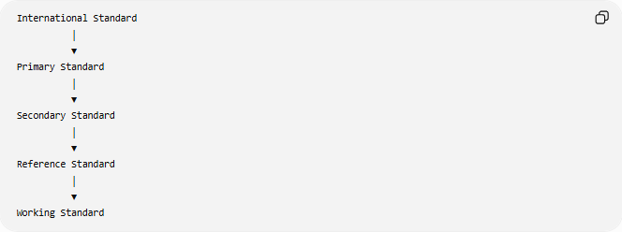
International Standard
│
▼
Primary Standard
│
▼
Secondary Standard
│
▼
Reference Standard
│
▼
Working Standard
Transfer standards can be used between different levels to compare or transport measurement accuracy.

Measurement Traceability
# Source: AI Source: Provided by: [Data Path: Persons Table -> ID Column: 1, Name_En Column: Motasem Essam] -> From: [ChatGPT] on [7/17/2026]
Measurement standards establish traceability, meaning every measurement can be related to an accepted reference through an unbroken chain of calibrations.
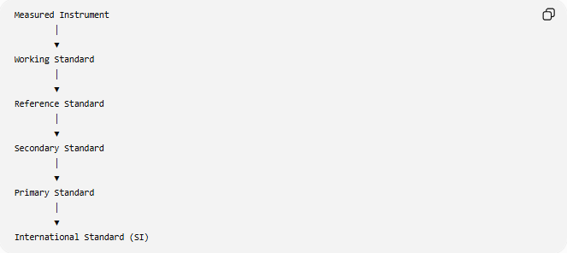
Measured Instrument
│
▼
Working Standard
│
▼
Reference Standard
│
▼
Secondary Standard
│
▼
Primary Standard
│
▼
International Standard (SI)

Examples of Measurement Standards
# Source: AI Source: Provided by: [Data Path: Persons Table -> ID Column: 1, Name_En Column: Motasem Essam] -> From: [ChatGPT] on [7/17/2026]
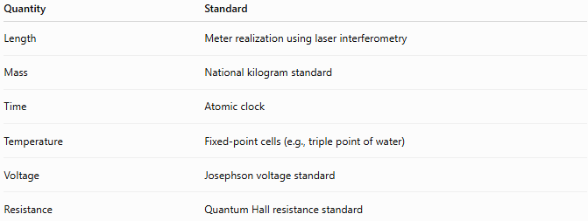
Quantity | Standard
Length | Meter realization using laser interferometry
Mass | National kilogram standard
Time | Atomic clock
Temperature | Fixed-point cells (e.g., triple point of water)
Voltage | Josephson voltage standard
Resistance | Quantum Hall resistance standard

Organizations Responsible for Standards
# Source: AI Source: Provided by: [Data Path: Persons Table -> ID Column: 1, Name_En Column: Motasem Essam] -> From: [ChatGPT] on [7/17/2026]
Several organizations maintain and coordinate measurement standards.
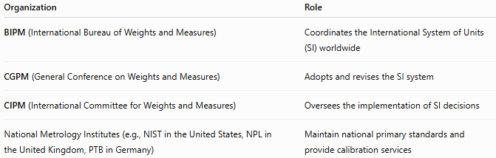
Organization | Role
BIPM (International Bureau of Weights and Measures) | Coordinates the International System of Units (SI) worldwide
CGPM (General Conference on Weights and Measures) | Adopts and revises the SI system
CIPM (International Committee for Weights and Measures) | Oversees the implementation of SI decisions
National Metrology Institutes (e.g., NIST in the United States, NPL in the United Kingdom, PTB in Germany) | Maintain national primary standards and provide calibration services

Applications
# Source: AI Source: Provided by: [Data Path: Persons Table -> ID Column: 1, Name_En Column: Motasem Essam] -> From: [ChatGPT] on [7/17/2026]
Measurement standards are essential in:
- Science
- Engineering
- Manufacturing
- Medicine
- Aerospace
- Construction
- Electronics
- Telecommunications
- Calibration laboratories
- International trade

Everyday Examples
# Source: AI Source: Provided by: [Data Path: Persons Table -> ID Column: 1, Name_En Column: Motasem Essam] -> From: [ChatGPT] on [7/17/2026]
Measurement standards are used when:
- Calibrating weighing scales.
- Verifying rulers and measuring tapes.
- Checking thermometers.
- Testing pressure gauges.
- Manufacturing precision machine parts.
- Certifying laboratory equipment.

Importance
# Source: AI Source: Provided by: [Data Path: Persons Table -> ID Column: 1, Name_En Column: Motasem Essam] -> From: [ChatGPT] on [7/17/2026]
Measurement standards provide:
- Measurement consistency.
- Instrument calibration.
- Product quality.
- International compatibility.
- Reliable scientific research.
- Fair commercial transactions.
- Legal compliance.

Common Mistakes
# Source: AI Source: Provided by: [Data Path: Persons Table -> ID Column: 1, Name_En Column: Motasem Essam] -> From: [ChatGPT] on [7/17/2026]
- Confusing measurement standards with measurement systems.
- Assuming all standards have the same level of accuracy.
- Using working standards without regular recalibration.
- Ignoring traceability requirements.

Key Points
# Source: AI Source: Provided by: [Data Path: Persons Table -> ID Column: 1, Name_En Column: Motasem Essam] -> From: [ChatGPT] on [7/17/2026]
- Measurement standards define and preserve units of measurement.
- They ensure accuracy, consistency, and traceability.
- Standards are organized in a hierarchy from international to working standards.
- Calibration links measurements to higher-level standards.
- Modern measurement standards are based on precisely defined physical constants and internationally agreed definitions.

Measurement Standards vs. Measurement Systems
# Source: AI Source: Provided by: [Data Path: Persons Table -> ID Column: 1, Name_En Column: Motasem Essam] -> From: [ChatGPT] on [7/17/2026]
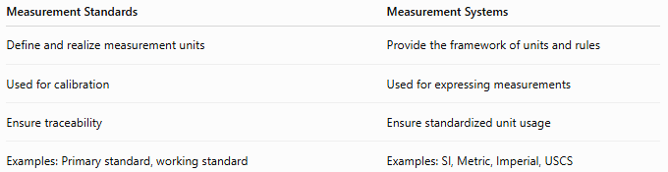
Measurement Standards | Measurement Systems
Define and realize measurement units | Provide the framework of units and rules
Used for calibration | Used for expressing measurements
Ensure traceability | Ensure standardized unit usage
Examples: Primary standard, working standard | Examples: SI, Metric, Imperial, USCS

Measurement Standards vs. Measuring Instruments
# Source: AI Source: Provided by: [Data Path: Persons Table -> ID Column: 1, Name_En Column: Motasem Essam] -> From: [ChatGPT] on [7/17/2026]
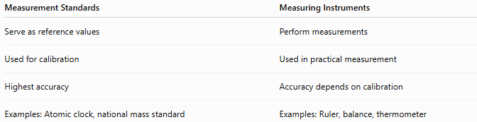
Measurement Standards | Measuring Instruments
Serve as reference values | Perform measurements
Used for calibration | Used in practical measurement
Highest accuracy | Accuracy depends on calibration
Examples: Atomic clock, national mass standard | Examples: Ruler, balance, thermometer

Conclusion
# Source: AI Source: Provided by: [Data Path: Persons Table -> ID Column: 1, Name_En Column: Motasem Essam] -> From: [ChatGPT] on [7/17/2026]
Measurement Standards are the official references that define, realize, maintain, and reproduce units of measurement. They ensure that measurements made anywhere in the world are accurate, consistent, comparable, and traceable. Organized in a hierarchy from international standards down to working standards, they form the foundation of modern metrology and are essential for science, engineering, manufacturing, healthcare, and international commerce.

